**Initial Preparation & Checklist and Deployment**

* Provision azure function app
* Enable FTP for azure function deployment
* Register azure ad app registration
* Create client certificate or use the existing one and upload it to the app-registration > certificate & secrets screen

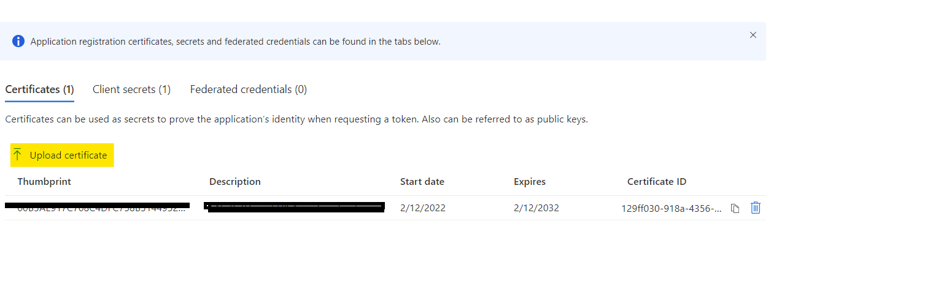

* Assign certificate permissions
* Copy certificate Thumbprint and keep it safe for later
* Assign function app permissions

**(Required Permissions)**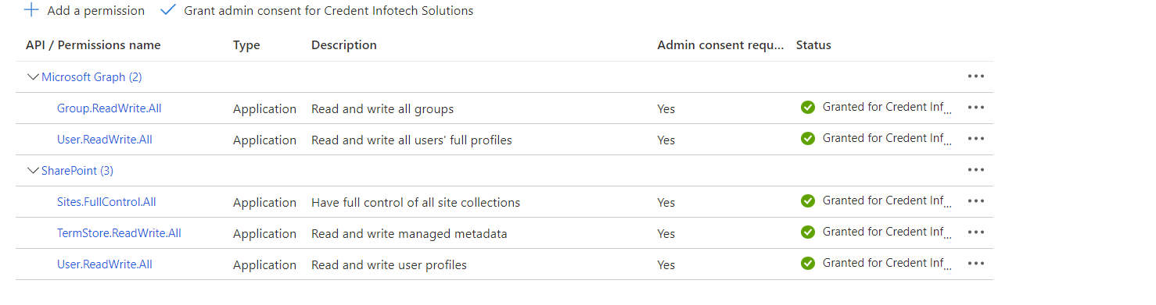

* Update Azure function configuration to store password of the existing or new certificate (as shown below)
* 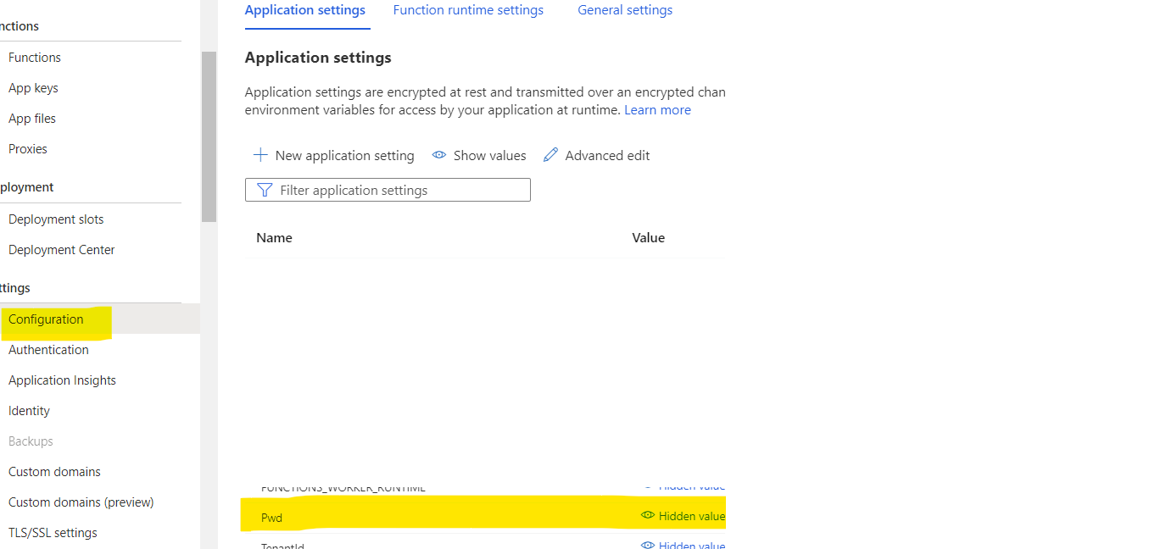

**Identity following configurations**

**SiteURL, TestPortal :** The sharepoint site for which the function will be working

**Tenant ID :** SharePoint TenantID

**ClientID** : App Registration ID

**Certificate Thumbprint :** copied while registering app in the Azure AD

**CertPath :** This is just the file name as the certification will be stored at the root path. Just change the name as per new file in case of new certificate

**Pwd:** this is Password for the certificate file

* 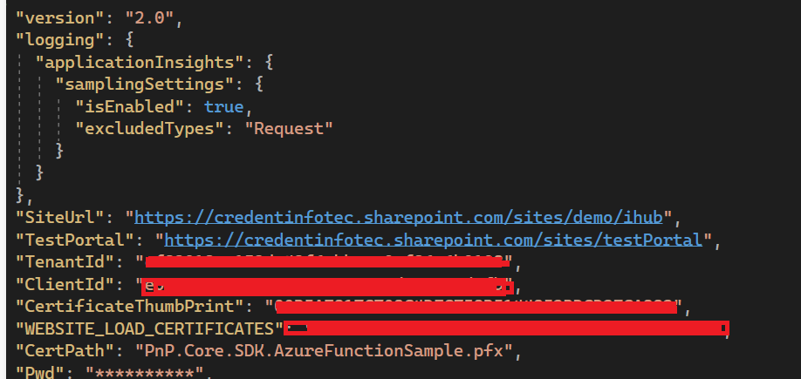

**Deployment**

* Publish the azure function solution as folder.
* Update configurations in host.json
* Upload folder to Azure function application’s FTP location
* Create azure function keys and replace them in the function call urls